# 

# WELCOME

Ms.

Ayaka

MAEMURA

Flight Arrival Date: 06 Apr 2019 Flight Arrival Time: 09:30 Flight Number: QF26

Homestay Address: Angela YAKOUMELOS , 8/11-17 Burleigh Street, Burwood, NSW, 2134

Telephone: 0412 435 650 Mobile: 0412 435 650

If you arrive at the International Airport:

Please meet your driver at the Royale Desk

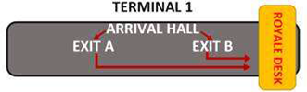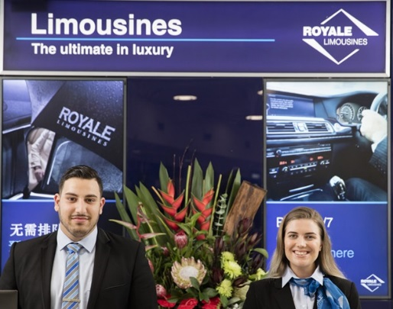

If you arrive at the Domestic Airport:

Please wait for your driver at the 'luggage area' as your driver will meet you there

In case of Emergency please contact:

Royale Limousine: (+61) 2 9660 3666

Global experience emergency number: (+61) 430 008 448

Email: [change@globalexperience.com.au](mailto:change@globalexperience.com.au)

PLEASE DO NOT LEAVE THE AIRPORT, WAIT FOR YOUR DRIVER